Senior Signing Day April 26th

Seniors! Submit a copy of your college/university acceptance letter of where you plan to attend.  Whether it's a 4-year, 2-year, or a vocational school, we want to recognize your accomplishment and next steps for your future.

Email a copy of your letter to Ms. Santiago by April 14th at: [santiagok@pcsb.org](mailto:santiagok@pcsb.org)  or follow this QR Code to each Senior TEAMS page below. Locate the assignment & upload your letter.

A-G H-O

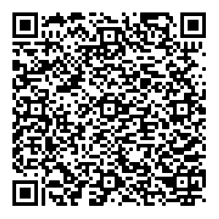 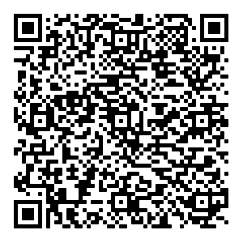

P-Z ISTEM

